**TOURISM AND HOSPITALITY**

**TOURISM AND HOSPITALITY**

* INTRODUCTION
* The hospitality industry is a broad category of fields within service industry that includes:

1. lodging
2. event planning
3. theme parks
4. transportation
5. cruise line
6. additional fields within the tourism industry

* Tourism is travel for pleasure or business; also the theory and practice of touring, the business of attracting, accommodating, and entertaining tourists, and the business of operating tours. the people, activities, and organizations involved in providing services for people on holidays.The service industries which benefit from tourism include transportation services, such as airlines, cruise ships, and taxicabs; hospitality services, such as accommodations, including hotels and resorts; and entertainment venues, such as amusement parks, casinos, shopping malls, music venues, and theaters.
* Hospitality and tourism workers help people enjoy vacations and entertainment activities. They might work at a restaurant, resort, sports arena, theme park, museum, or hotel.

**Forms of tourism**

There are different purpose of visits:

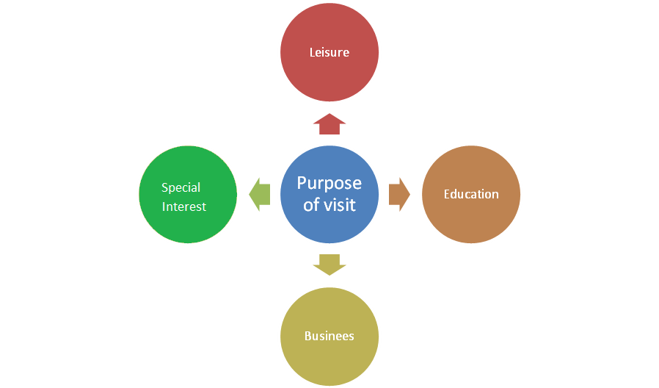

**TOURISM**

Based on the purpose of visit, tourism is categorized into the following:

* Leisure tourism
* Cultural tourism
* Religious tourism
* Family tourism
* Health tourism
* Sport tourism
* Educational tourism
* Business tourism
* Alternative forms of tourism

Leisure tourism

Tourists may travel to experience a change in climate and place and learn something new, enjoy pleasant scenery, or to know more about the culture of a destination. Tourists, who seek break from the stress of day to day life, devote their holiday to rest and relaxation, refresh themselves. These tourists prefer to stay in some quiet and relaxed destination preferably at a hill resort, beach resort or island resort. Nowadays tourists undertake various adventure sports activities for leisure and to refresh themselves after working hard. Leisure tourism contains information from the leisure, recreation, sport, hospitality, tourism and culture sectors, including academic research, industry reports, books, conferences and news.

Cultural tourism

Cultural Tourismis the subset of tourism concerned with a traveler's engagement with a country or region's culture, specifically the lifestyle of the people in those geographical areas, the history of those people, their art, architecture, religions, and other elements that helped shape their way of life.

Cultural tourism includes tourism in urban areas, particularly historic or large cities and their cultural facilities such as museums and theatres. It can also include tourism in rural areas showcasing the traditions of indigenous cultural communities includes festivals and rituals,and their values and lifestyle, as well as niches like industrial tourism and creative tourism.It is also called as heritage tourism.

Religious tourism

Religious tourism, also commonly referred to as faith tourism.It is also called as Pilgrimage tourism / Spiritual tourism.Faith tourism is a type of tourism, where people travel individually or in groups for pilgrimage, missionary, or leisure purposes. The world's largest form of mass religious tourism takes place at the annual Hajj pilgrimage in Mecca, Saudi Arabia. Modern religious tourists are more able to visit holy cities and holy sites around the world.People visiting these kinds of places for some reasons :

1. to understand and appreciate their religion through a tangible experience
2. to feel secure about their religious beliefs
3. to connect personally to the holy city

Family tourism

Family tourism involves the family unit and their participation in diverse forms of tourism activity. This includes visiting one’s relatives and friends for interpersonal reasons. Many people in India travel for visiting their friends and relatives. While visiting friends or relatives, people also visit tourists’ attractions in and around the city

Health tourism

Health tourism is also called as Medical tourism.Health tourism is the practice of traveling to a tourist destination with the main purpose of receiving some therapeutic treatment.Health Tourism is also defined as travelling to another city for the purpose of receiving medical or wellness services.

It is divided into two categories:

* Health Tourism: travelling to receive medical treatment in specialized institutions jointly with tourism programs.
* Wellness Tourism: healthy people travelling to other cities to maintain their physical and psychological health through receiving certain services in specialized institutions.

Sports tourism

Sports tourism refers to travel which involves either observing or participating in a sporting event staying apart from their usual environment. Sports Tourism refers to travel which involves either viewing or participating in a sporting event staying apart from their usual environment. Normally these kinds of events are the motivators that attract visitors to visit the events like Olympic Games, FIFA World Cup. Sports tourism can be adventurous also. Adventure sport tourism is also called as Adventure tourism. Adventure sport tourism is more challenging because it takes the tourists into regions which are less frequently visited and may not have easy access.Sport tourism is a fast-growing sector of the global travel industry nowadays.

Adventure tourism has various forms, which can be broadly categorized as follows:

* Land adventure
* Water adventure
* Aerial adventure

Educational tourism

Educational tourism developed, because of the growing popularity of teaching and learning of knowledge and the enhancing of technical competency outside of the classroom environment. In educational tourism, the main focus of the tour visiting another country to learn about the culture, such as in Student Exchange Programs and Study Tours, organizing specialized lectures of the eminent personalities and for research.

Business tourism

Business tourism or business travel is a more limited and focused subset of regular tourism. The business travelers main motive for travel is work. Tourists visit a particular destination for various reasons pertaining to his /her work such as attending a business meeting, conferences, conventions selling products, meeting clientsDuring business tourism (traveling), individuals are still working and being paid, but are doing so away from both their workplace and home.

Business tourism is popularly called as MICE :

* Meetings
* Incentives
* Conferences
* Exhibitions

Alternative forms of tourism

Alternative tourism combines tourist products or individual tourist services, different from the mass tourism by means of supply, organization and the human resource involved.Alternative tourism aims at seeking a change from impersonal, traditional tourism to establishing cardinal rapport between visitors and the local community. Instead of using touristic commodities these tourists prefer to use or share the services of local people. The focus in these travels is the preserved natural environment, authentic atmosphere and cuisine, and local traditions.

Alternative tourism is nowadays regarded as a key to sustainable development. It is also known as special interest tourism.

It is of various types:

* Ecotourism
* Food tourism
* Agro-rural tourism

5 Different sectors of the hospitality industry :

* Lodging Accommodation
* Food and beverage
* Travel and tourism
* Entertainment industry
* Timeshare

**Lodging Accommodation**

* Lodging or a holiday accommodation is a type of residential accommodation.
* People who travel and stay away from house for more than a day need lodging for sleep, rest, food, safety, shelter from cold temperatures or rain, storage of luggage and access to common household functions.
* Lodgings may be self-catering, in which case no food is provided, but cooking facilities are available.
* Lodging is done in a hotel, motel, hostel or hostal, a private home (commercial,that is. a bed and breakfast, a guest house, a vacation rental, or non-commercially,with members of hospitality services or in the home of friends), in a tent, caravan/camper (mostly on a campsite).
* People needs three things mainly whenever they started to travelling.

1. Accommodations
2. Food
3. Transportations

* Due to above fact,5 factors of the hospitality industry started with lodging .
* If you have arranged hotel and accomodations,automatically you will able to find other two things too. (Food & Transportation)
* All the managements all around the world, are focusing a lot nowadays to improve the lodging experience and give the best to people whom travelling.

Below are five main types of hotel and accommodations services :

* Motel
* Originally designed for motorists, motels are roadside hotels equipped with minimal amenities and ample parking areas for motor vehicles.
* Backpacker Hostel
* A hostel (or backpacker) establishment is aimed at the budget traveller and generally attracts a younger clientele.
* Bedrooms are in a dormitory style (shared) and bathrooms are shared, although private bedrooms may be available.
* Light meals may be available in addition to the room rate.
* Resort

A spread out collection of single or double story accommodation units.Similar to a hotel in that it offers a wide range of facilities.Units may be rented and available on time-share.A camping area may be included in the resort.

* Lodge

A lodge is an accommodation facility which is located and designed to optimize the feeling of being closely in touch with nature.The building style should feature natural materials and colouring such as wood, stone and thatch.An outdoor experience should be offered at the lodge, such as guided walks, game drives etc.

* Boutique Hotel

A boutique hotel is a 5 star establishment providing all the features and facilities of a normal hotel, in a unique and exclusive style.

These properties are generally small, feature top class service and are marketed to the affluent.

* In this post,I tried to answer a key question about the different sectors of the hospitality industry and also also brief about hotel accommodations .I also made a lot effort to involve on these sectors to take a holistics approach towards presenting the view of hospitality industry.The hospitality industry is having a graceful and elegant bearing to grow in future with the help of developing technologies and some improved management skills.
* The need of the hour demands businesses operating in this field to embrace and adopt these technological changes and strategize accordingly, so it can keep pace with rest of the world.